Farhad Ramezanghorbani HW4

#function########################################
def matrix_import(): # this function will get column and
Listoflist = [] # row of matrix from user then it will
print "enter matrix dimensions" # get each of matrix elements from
rowm = int(raw_input("rows: ")) # user and put them in a list of list
colm = int(raw_input("columns: "))

print "\nenter matrix elements"
for i in range(rowm):
List = []
for j in range(colm):
xm = int(raw_input("enter %d,%d element of matrix: " %(i+1,j+1)))
List.append(xm)
Listoflist.append(List)
return Listoflist

#function########################################
def matrix_represent(M): # this function will show matrix
for row in M: # representation of a list
for element in row:
print element,
print

#function########################################
def convert_todict(L): # this function will convert a list
dictL = {} # to a dictionary in which there is
rowL = len(L) # no key with zero value. it has the
colL = len(L[0]) # row and column of sparse matrix
for i in range(rowL):
for j in range(colL):
if L[i][j] != 0:
dictL[i+1,j+1] = L[i][j]
dictL['row'] = rowL
dictL['col'] = colL
return dictL

#function########################################
def convert_tolist(D): # this function will convert a dict.
# of non zero elements of sparse matrix
Listoflist = [] # to a list in which we have the zero
rowL = D['row'] # elements also, then we can see the
colL = D['col'] # matrix representation of this list
for i in range(rowL):
List = []
for j in range(colL):
if D.has_key((i+1,j+1)) == 1:
List.append(D[i+1,j+1])
else:
List.append(0)
Listoflist.append(List)
return Listoflist

#function########################################
def addsparse_dict(Da,Db): # in matrix summation for less calculation
Dc = {} # it is better to omit the zero elements of
rowa = Da['row'] # matrices, it means that we can use sparse
cola = Da['col'] # dictionaries for calculation. this function
rowb = Db['row'] # will add two sparse matrix
colb = Db['col']
if (rowa == rowb and cola == colb):
Dc['row'] = rowa
Dc['col'] = cola
for i in range(rowa):
for j in range(cola):

if (Da.has_key((i+1,j+1)) == 1 and Db.has_key((i+1,j+1)) == 1):
Dc[i+1,j+1] = Da[i+1,j+1] + Db[i+1,j+1]
elif (Da.has_key((i+1,j+1)) == 1):
Dc[i+1,j+1] = Da[i+1,j+1]
elif (Db.has_key((i+1,j+1)) == 1):
Dc[i+1,j+1] = Db[i+1,j+1]
if (Dc.has_key((i+1,j+1)) == 1):
if (Dc[i+1,j+1] == 0):
del Dc[i+1,j+1]

return Dc
else:
print "\nfor addition two matrices should have same dimentions!"

#function########################################
def multiplyab_dict(Da,Db): # this function uses dictionary for matrix
Dc = {} # multiplication
if (Da['col'] == Db['row']):
Dc['row'] = Da['row']
Dc['col'] = Db['col']
for i in range(Da['row']):
for j in range(Db['col']):
c = 0
for k in range(Da['col']):
if (Da.has_key((i+1,k+1)) == 1 and Db.has_key((k+1,j+1)) == 1):
c += Da[i+1,k+1]*Db[k+1,j+1]
if (c!=0):
Dc[i+1,j+1] = c

return Dc
else:
print "\nfor multiplication #of column of A should be equal to #of row of B!"

#################################################

#print "import matrix A:" # generally we should use these four lines
#A = matrix_import() # but for just seeing the result I wrote two
#print "\nimport matrix B:" # list as A and B matrices with same dimention
#B = matrix_import() # of 3x3 in following lines

##for test
A = [[-1,1,0],[0,0,1],[7,0,9]]
B = [[1,0,0],[1,0,0],[1,0,1]]

print "\nthese are your A & B matrices and their dictionaries:\n\nA:"
matrix_represent(A) # matrix representation of A
dictA = convert_todict(A) # convert nonzero values of A to a dictionary type
print dictA
Lista = convert_tolist(dictA)
print Lista # show the list representation

print "\nB:"
matrix_represent(B)
dictB = convert_todict(B)
print dictB
Listb = convert_tolist(dictB)
print Listb

print
dictC = addsparse_dict(dictA,dictB) # add A and B (dictionaries)
print "DictA + DictB is:",dictC # show the dict. representation
if (dictC != None): # for the case that A and B have not same dimension
ListC = convert_tolist(dictC) # convert the result to list to see the matrix repres.
matrix_represent(ListC)
print

dictD = multiplyab_dict(dictA,dictB) # multiply A and B (dictionaries)
print "A*B is:", dictD # show the dict. representation
if (dictD!=None): # for the case that columnA != rowB
ListD = convert_tolist(dictD)
matrix_represent(ListD)

print

#################################################

This is the result for sample input for 3x3 matrices:

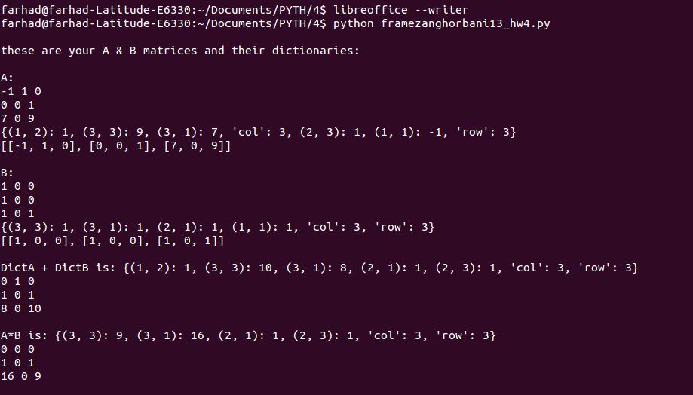

For 2x3 and 3x3 matrices:

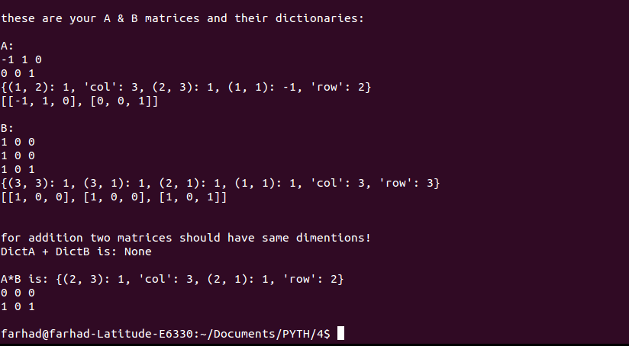

And in next page you can see the result for 5x5 matrices:

